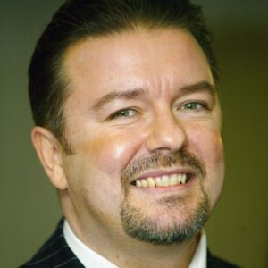
Task 3 - Fill in the gaps with the correct form of the words in brackets.
Team number:
Score: ____ out of 10
Ricky Gervais is a British ……….. ₁(comedy) and television producer. He co-created the popular mockumentary television series The Office with his friend Stephen Merchant. Gervais also created the sitcom Extras for both the BBC and HBO. In 2005, his video podcast, The Ricky Gervais Show, …………₂(become) one of the most popular downloads on the Internet. Gervais has also ………. ₃(write) children's books, including Flanimals.
Excelling at school, Gervais went on to ………..₄(study) at University College London where he earned a degree in philosophy. Gervais spent several of his post-graduate years ……….. ₅(work) for the university, hiring bands to play there. For a while, he also pursued his own musical aspirations as the lead singer of a new-wave rock group called Seona Dancing.
For his efforts on The Office, he won the Golden Globe Award for …….. ₆ (good) Performance by an Actor in a Television Series - Musical or Comedy in 2004. Gervais launched two new television projects the following year, Extras and an American version of The Office starring Steve Carell. On Extras, he and Merchant wrote a behind-the-scenes comedy about Hollywood.
Besides his work on film and stage, Gervais is also an author. He has written several children's books about …………. ₇(imagine) animals, including Flanimals (2005) and Flanimals Pop-Up (2010). The desire to make up these fictional …………₈ (create) came from his childhood. "The first thing I wanted to be was a marine …………….₉ (biology). Then I wanted to be a vet," Gervais told Entertainment Weekly. These characters will soon find their way to the big screen in the form of an upcoming animated film.
Gervais lives in London with his girlfriend Jane Fallon, a television producer. The couple has …….. ₁₀ (be) together for more than 20 years.

